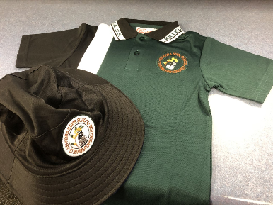

**Order**

1. **Place your Order**

On the app home screen, scroll down to view your school services such as tuckshop and uniforms.Then **swipe left and right** to view all available services.

1. **Make your Selection**

Find the service and press **‘Order’** then select the items you wish to order.

1. **Make Payment**

Select your payment option and complete payment to place your order.

**Set up your Account:**

1. Download the Flexischools App

Note: for iPhone and iPad please select

‘Allow’ notifications.

1. **Login/Register**

**Already a Flexischools user** -

Enter your details and login.

To save your login details select ‘remember me’.

**New Flexischools user** –

Click **‘Register’,** enter your email address and follow the instructions in the email to set up your account. Once your account is set up, add new student: search for their school, enter student details and select their class.

1. **Top Up your Account**

To make ordering fast and simple, you can set up automatic top ups in your **‘User Profile’.**

Cashless Online Tuckshop and Uniform Ordering is available

No more looking for cash

No more filling out order forms

No More looking for pricelists

Simple and easy to use online ordering from your smart phone or computer 24/7!

<https://www.flexischools.com.au.>

Cashless Online Uniform