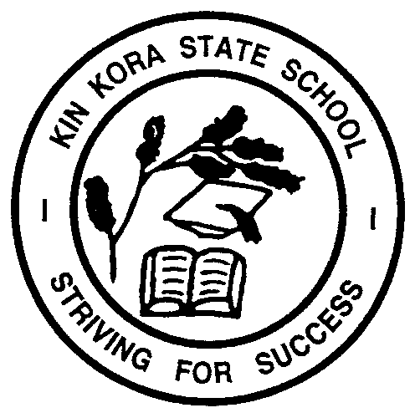

KIN KORA STATE SCHOOL
PARENTS AND CITIZENS ASSOCIATION

Hibiscus Avenue, Gladstone, Qld 4680
Telephone (07) 4971 5111

KIN KORA STATE SCHOOL TUCKSHOP

The Tuckshop is open on Wednesdays, Thursdays and Fridays for Flexischools (online ordering) and Over the Counter purchases. As Preps do not come to the Tuckshop to purchase food, lunch has to be pre-ordered via Flexischools or before school (Tuckshop will be open from 8am to 8:30am for brown paper bag orders) Instructions on how to register for Flexischools can be found on the school website and Flexischools can also be used for ordering Uniforms.

We rely on volunteers to provide freshly made, nutritious meals for our students and volunteers are greatly appreciated. Volunteer shifts are from 9:00am to 11:30am or any time that is suitable to you. By volunteering your time, it allows the profits from the Tuckshop to be passed on to the P & C Association to help fund worthwhile projects within our school. All training is provided and a cuppa and lunch is on us.

This is a great opportunity to be involved in your child / children’s school, have an input into the Tuckshop, meet and make new friends, have fun and help out your school community.

You are more than welcome to come along and see me at the Tuckshop or contact me via telephone or email to have a chat or if you have any questions.

Thank you and I look forward to meeting you soon.

Brenda Raw

Tuckshop Managing Convenor.
Kin Kora State School
Phone: (07) 4971 5128 / Email: kinkorasstuckshop@yahoo.com

