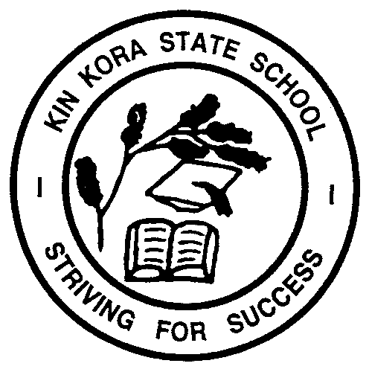

KIN KORA STATE SCHOOL
PARENTS AND CITIZENS ASSOCIATION

Hibiscus Avenue, Gladstone, Qld 4680
Telephone 07 4971 5111

UNIFORM SHOP

Our Uniform Shop is operated by our P&C Association, which has endorsed the school uniform policy. Kin Kora State School is a proud uniform school, for reasons of safety, students must wear their school uniform every day, we ask for parent support in ensuring your child is correctly attired each day. All school uniform requirements are available from the uniform shop, with the exception of socks & shoes.

Hats: Black reversible bucket hats – reverse side colour according to sports house (can also be purchased from School Office)
Shirt: Bottle green, black and white polo
Sports Shirts: Can be worn on a Friday
Short or Skort: Black (bottoms with KKSS logo are now available)
Shoes: Black sport shoes (preferred)
Socks: White
Jackets/Jumpers: Black (Jackets & jumpers with the KKSS logo are now available)
no hoodies or prints allowed
Dress: Bottle green, black and white check
Hair: Hair ties and clips are to be KKSS colours – green, white, black.
no large coloured bows

Please note all students are to wear shorts or skorts. The wearing of leggings or active wear is not permitted.

Our preferred method of payment is via Flexischools online ordering – see attached flyer

The Uniform Shop has a Refunds and Returns Policy – available on the School Website

We also accept cash, eftpos, Mastercard and Visa – Lay-by option available please see Application form for terms and conditions.

Normal opening hours for the Uniform Shop are:

​TUESDAY: | ​8.30am to 10.30am (term time only)
The store is located in Amenities 2 – Opposite G Block (toilet block at Sunvalley Rd end of school).

